

Skill level: No experience required

Age: **6 – 14yr**

Time: 9:00 - 4:30pm; Lunch 12:30 – 1:30

**DISCOUNT PRICE before MAY 1st:**

**$250 whole camp OR $60 per day.**

**10% Discount for friends & family signing up together**

**AFTER** MAY 1ST PRICE: $300 whole camp OR $80 per day

Campers Should Bring : Lunch, snacks and water bottle, athletic indoor shoes, T-shirt and track pants (absolutely no shorts when fencing!)

Camp itinerary: morning stretching, warm-up games, fencing. After lunch: fencing plus other sporting games like badminton, volleyball, soccer, basketball, Frisbee etc.

## We Provide ALL of the Equipment!

## Try something NEW this Summer! Our Camp will teach your kids about Olympic sport of FENCING and healthy lifestyle habits. Campers will be daily learning fencing plus play other sports and sporting activities!

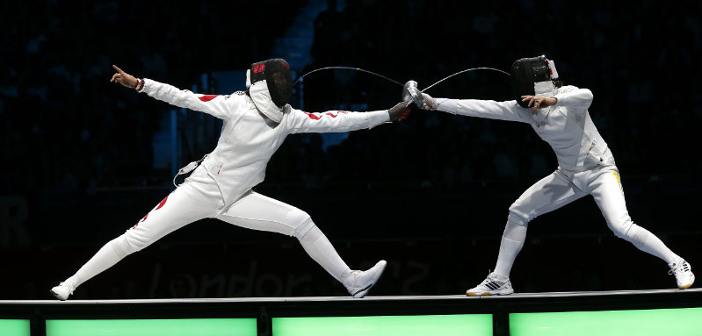

Camp Head Coach

**Tim Svidnytskiy**

* Member of Ontario College of Teachers
* Western University – BA. Ed
* Brock University – BA. Kin
* Coach of Team Canada Members

Questions? Do not hesitate to contact our coach! 647-972-5589 [FENCINGCOACHTIM@GMAIL.COM](mailto:FENCINGCOACHTIM@GMAIL.COM)

**FENCINGCOACHTIM.CA**

**OR**

**TORONTOFENCING.COM**



**To Register** Circle Camp ‘A’ or ‘B’

Fill out registration section **HERE 🡪**

Email filled out form with payment to: [FENCINGCOACHTIM@GMAIL.COM](mailto:FENCINGCOACHTIM@GMAIL.COM)

**Payment Option**:

1. E- Transfer to: [FENCINGCOACHTIM@GMAIL.COM](mailto:FENCINGCOACHTIM@GMAIL.COM)
2. Cheque made out and mailed to:

Coach Tim Inc.

802-2335 Lake Shore Boulevard West; Toronto, ON M8V 1B9

Location:

## Toronto Fencing Club

50 Prince Andrew Place, Toronto, ON

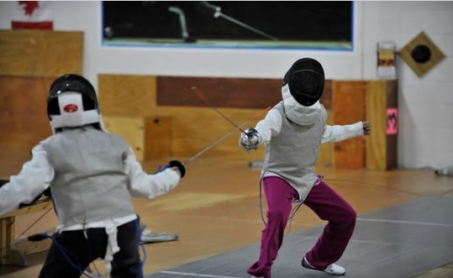

* **FILL OUT REGISTRATION SECTION BELOW**

